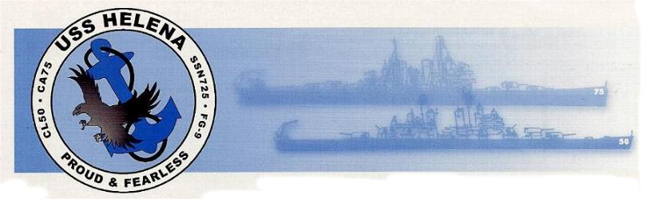
PG9 |  | CL50 |  | CA75 |  | SSN725
USS HELENA ORGANIZATION
1340 Spring Lakes Xing, Opelika, AL 36801
The USS HELENA ORGANIZATION is a non-profit founded in the 1950's to keep in touch with friends who we have served on the USS Helena. The original members were aboard the CL50. During the 1970's, CA75 members came aboard. In 1987 SSN725 was commissioned (nuclear attack submarine) and crew members joined the organization.
We publish a muster with complete addresses and military information, mail out bulletins to keep you posted on happenings and make arrangements for reunions every TWO years. It is a great way to stay in touch with old shipmates and to see friends we have been out of contact with for many years.
We must collect dues for mailing, printing and office expense. There are no paid employees and all work is done by volunteers of the Helena Organization. Our dues are $20 for two years or $100 for life membership.
Check payable to the USS HELENA ORGANIZATION. (address above)
Upon receipt of dues, you will be issued your I.D. card and placed on the mailing list.
This organization is for former officer, enlisted and marines. (Relatives are also invited to join).
Please furnish the following information:
Date of application: __________________________
NAME____________________________________________________SPOUSE_________________________________________________
ADDRESS_________________________________________________________________________________________________________
PHONE / TEXT NUMBER ____________________________________ E-MAIL_________________________________________________
VESSEL # _______________________ DIVISION ________________ RANK / RATE ____________________
DATES ABOARD ____________________________________
BRIEF BIOGRAPHY: ____________________________________________________________________
__________________________________________________________________________________________________________________________________________________________________________
_____________________________________________________________________________________

